
K&M Tire

Director of Sales
Version 1.0
03/15/2021

Document Number:
Contract Number:

Table of Contents
1. K&M Tire 1
1.2 Important Company Information 3
2. Director of Sales Manual Introduction 5
3. Welcome 6
4. Overview 7
4.1 Conventions 7
4.2 Cautions & Warnings 7
5. Daily Duties 8
6. Daily Monthly 16
7. Frequently Asked Questions 33
8. Other 34
Appendix A: Miscellaneous 35
Appendix B: Supportive Department Summaries 36
Appendix C: Glossary 37
Appendix D: Referenced Documents 38
Appendix E: Approvals 40
Appendix F: Additional Appendices 41
Appendix G: Notes to the Author/Template Instructions 42
Appendix H: Revision History Tracking 43

- List of Figures
No table of figures entries found.

- List of Tables
Table 1 - Support Points of Contact 115
Table 2 - Acronyms 119
Table 3 - Glossary 121
Table 4 - Referenced Documents 122
Table 5 - Approvals 124
Table 6 - Revision History Tracking 127

K&M Tire
Video about K&M Tire
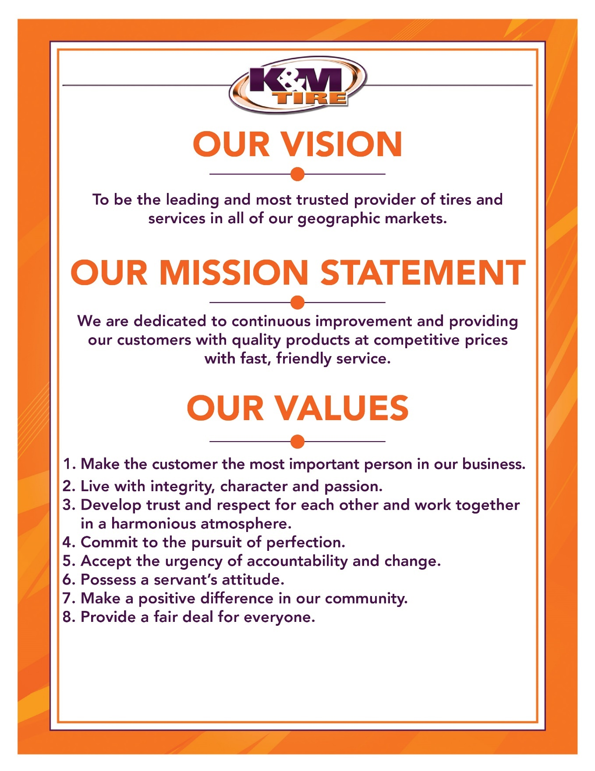



1.1 K&M Timeline


Important Company Information
This information is updated frequently. To ensure you are viewing the most current and accurate information, please use the links to access each document.

Employee Handbook
Employee Handbook can be found in Paylocity under Self – Service Portal then unemployment and is accessible HERE.

Organizational Chart
The organizational chart is a breakdown showing who is on each team and the chain of command throughout the entire company starting with the CEO and President. It is maintained on Paylocity and is accessible HERE.

Our Locations:
http://kmtire.com/km-cgi/distmap

Warehouse Locations - Contact Information
The Warehouse Locations – Contact Information is a Word document listing each of our warehouse locations’ addresses, a phone number to reach the warehouse/manager, the manager’s name and an email address for to reach the warehouse manager directly as well as a “location” email. When sending an email to the location email address, it will be sent to anyone associated with that warehouse who has an active email address. This list is maintained by our Human Resources department and can be found on the F: Drive. You can also view the list by clicking HERE.

Director of Sales Manual Introduction

This manual is intended to provide helpful information for Director of Sales positions with K&M Tire. It will be especially helpful for those newly hired or new to the Director of Sales position. There will be some step-by-step procedural suggestions. This manual, however, does not replace the necessity to work closely with the VP of Sales for guidance when needed.

Welcome
Welcome to the K&M Tire family and Outside Sales Team! We are pleased you decided to become part of our positive culture and strive to make our company the leading and most trusted tire distributor. Our #1 Value is to make the customer the most important person in our business, and that starts with you. Congratulations on your new position of Director of Sales. Your main goal will be to become the Best Servant Leader Possible. You will work hand and hand with each RSM, ISM, CSM, ASM, OSR and VP of Sales. Communication is vitally important to be affective in this position. Your main role is to support everyone in the sales department. The RSM SOP reflects your responsibility’s as well. This SOP will walk you through specific duties you have and will give you step by step instruction.

Overview

Conventions
This document provides screen prints and corresponding narrative to describe how to use the Maddenco, Weblink and K&M Intranet, known as “company systems”
Note: The term ‘user’ is used throughout this document to refer to a person who requires and/or has acquired access to the company systems.

Cautions & Warnings
This manual does not supersede any safety or company policy.

Daily Duties

- Read Telenotes
  - The more Telenotes you read the more effective you will become. It’s hard for one person to always see an opportunity. More people reading Telenotes means more opportunities captured.
- Review Price Level Changes
  - RSM’s will send you price level change request periodically. The Price Level Change Request Form is in the F-drive.
  - Price Level Request Form

  - It’s your duty to make sure the price level requests makes sense. (Did the OSR do their homework? Will we sell more tires? Will we increase GP?) Here are some tools in the intranet you will use to make a good decision.
SA - Sales Analysis/Product History Report
SA - Vendor Programs Report
SA - Weblink Login Report
SA - Customer Ranking Report
  - Steps to change Price Levels in Maddenco
- 1 - Tire Dealer System
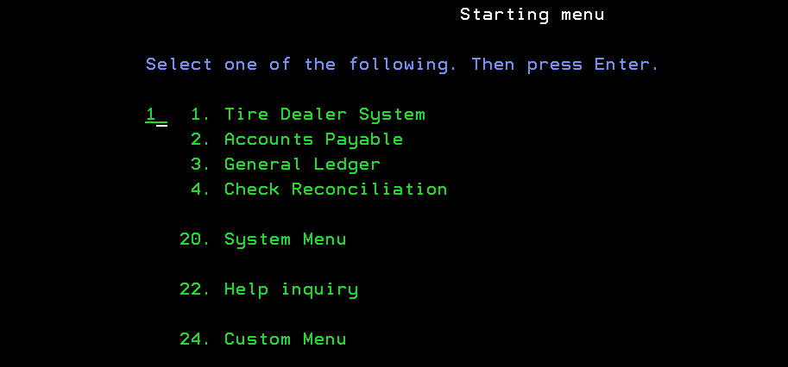
- 1 – Account Receivable Menu
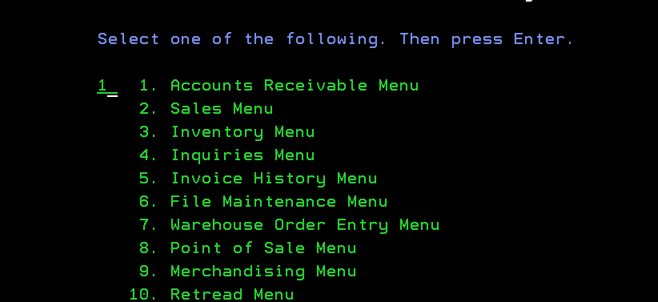
- 1 – Customer Maintenance Menu
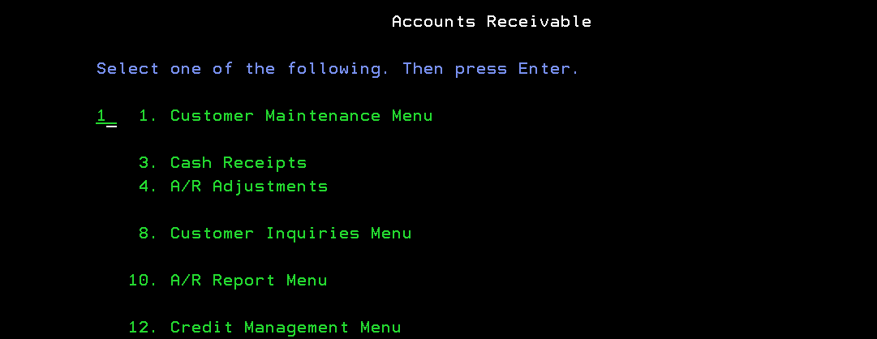
- 1 – Customer Maintenance
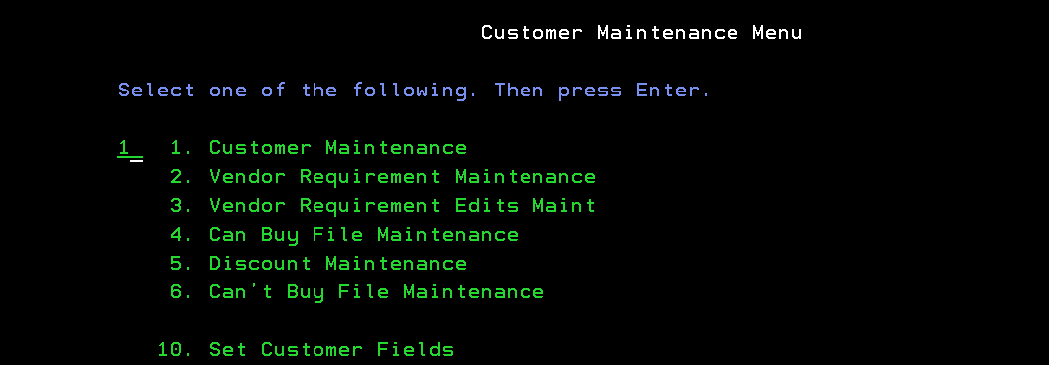
- Enter the store number to be used : 001
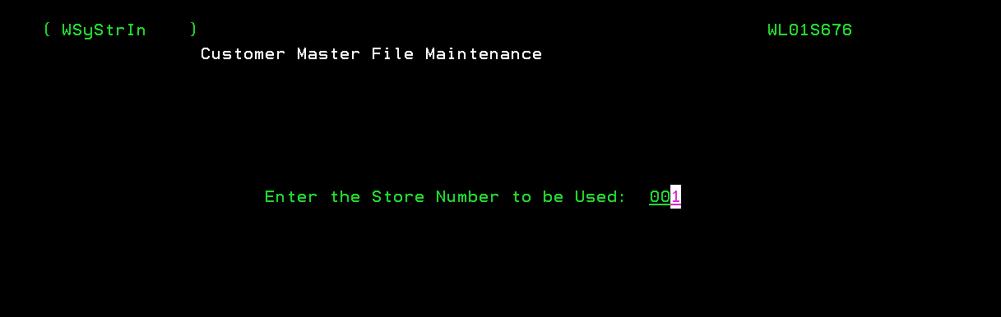
- Type customer number in the blank
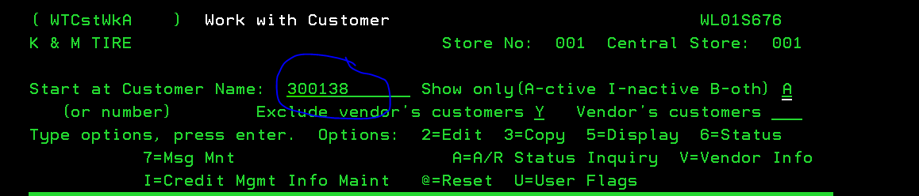
- Hit enter
  - Sometime the discount structure is different than the account #. Make sure you look for the discount structure. It will be here.
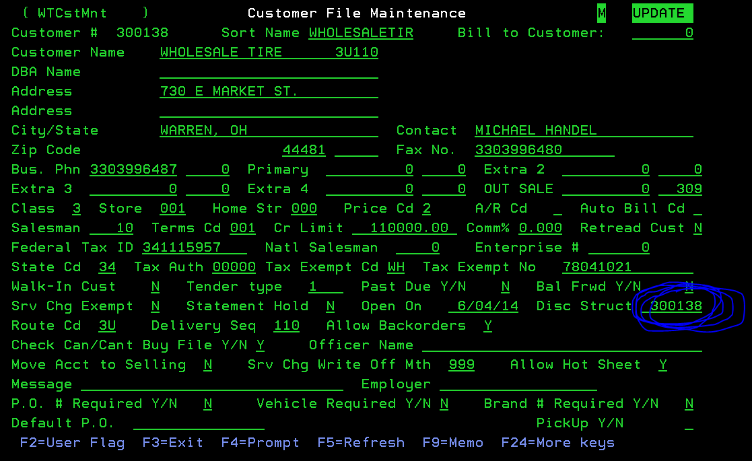
- Hit F3 (x2) will take you back to Customer Maintenance.
- Put a 5 in for Discount Maintenance
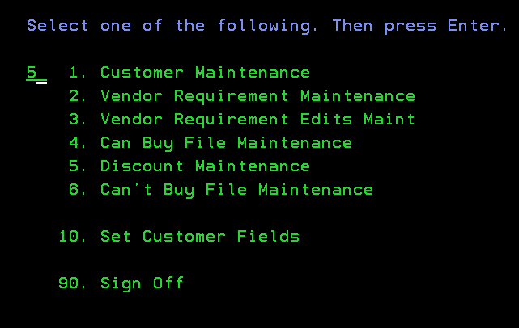
- Hit Enter
- Store # use: 001
- Put discount structure # in here
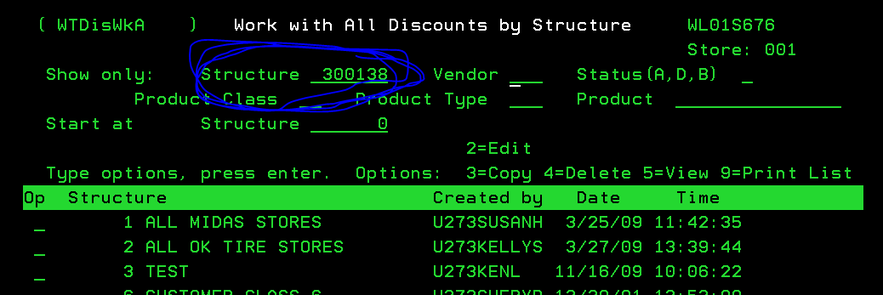
- Hit Enter

- Put a 2 next to a discount structure you would like to change, 4 next to a discount structure you would like to delete or F6 to create a new discount structure.
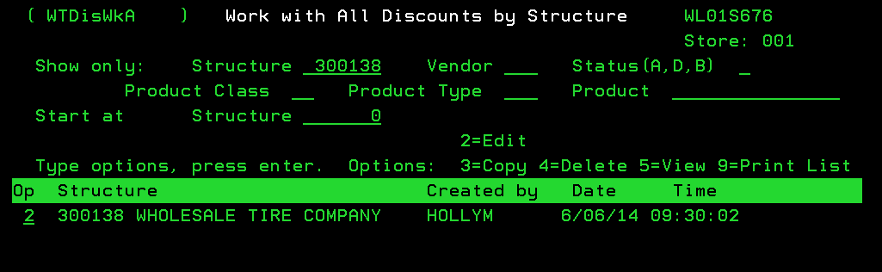
  - Below is an example of what you will change.
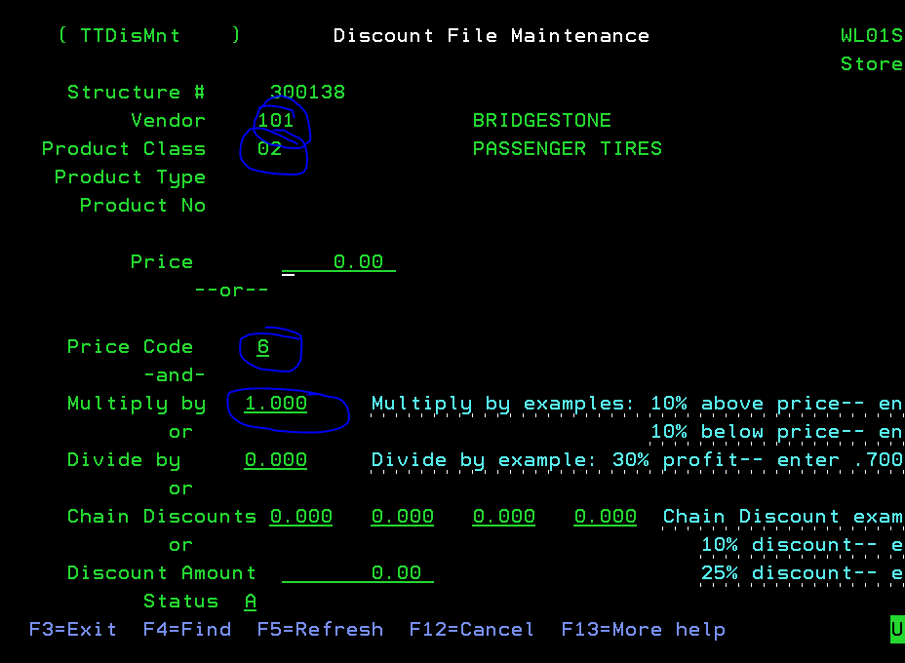
- Vender, class, price level and sometimes multiply by. For instance, you might want Hankook at PL2 -5%. This is what would like.
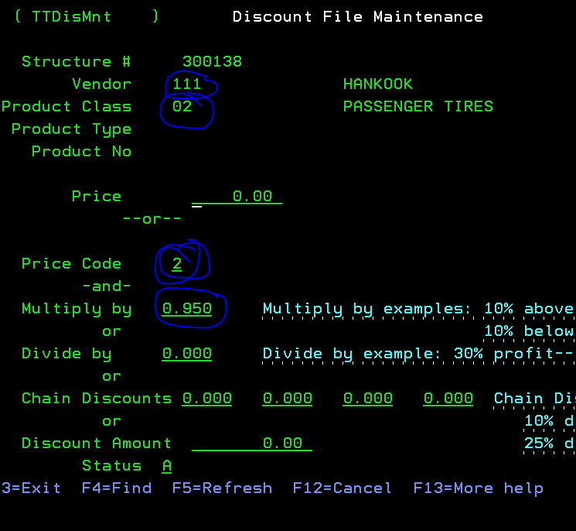
  - After adjusting pricing email the RSM that requested the price level change to let them know it is complete. You will also want to save the email to the F: Drive. under Price Exceptions
  - Schedule a date to make sure price level changes worked and if not return to normal pricing. Make sure to put the email in the correct location folder. This will help when you need to research something.
- Review Concur receipts
  - Log into concur to approve expense reports. Concur
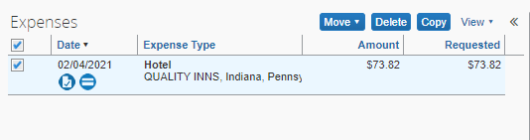
  - You must verify the following is correct Expense type, transaction date, business purpose, vendor, payment type, amount & location.
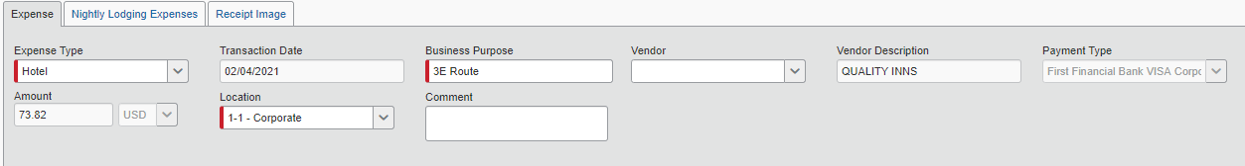
  - If everything is correct Approve and if not Send back to employee. Then call the employee to explain what they need to fix before resubmitting.
- Work with new hires on training
  - Work with each RSM to make sure all new hires getting the proper and consistent training. There is a Training Plan check list in the F-drive. When new hire training is still in progress file training plan in the (Outside Sales Training Plans in Progress). When training is complete move it to (Outside Sales Training Plans Complete). Every time you converse with a new hire take the time to explain why at least one thing in our Vision, Mission and Values is so important to us.
Outside Sales Rep. Training Plans

  - You will also set up Telenotes for all new employees. Go to Telenotes
& Click Support.
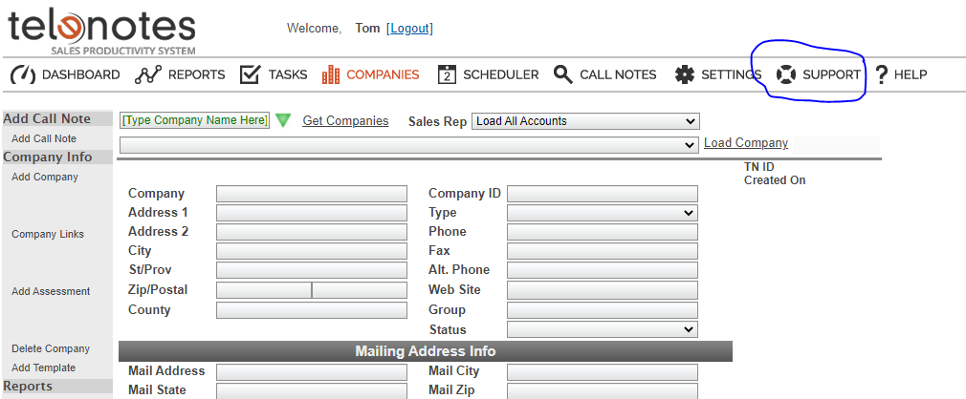

Type a brief message with the new employees name, email, who the employee might have replace, who they report to & each of our employees that will need to see their notes. (Make sure in the message you inform Telenotes they can use a past employees setup, if not they will charge us extra for a new one.) You and the new employee will get an email from Telenotes once they are set up. Forward that email on to the RSM in charge, so they can complete the Telenotes Training.
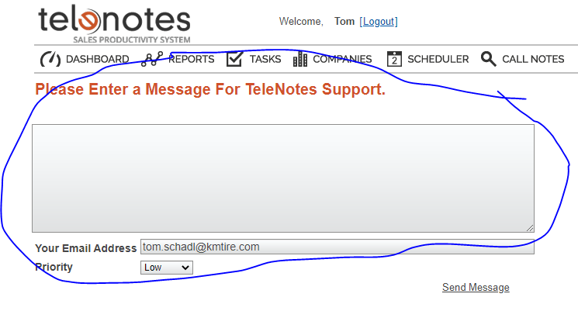

Daily Monthly
- Update Telenotes report the 1st of each month.
  - F:\Sales\Shared\Director of Sales\Monthly Telenotes
  - Telenotes
- Go to reports, enter date range & select Sales Activities
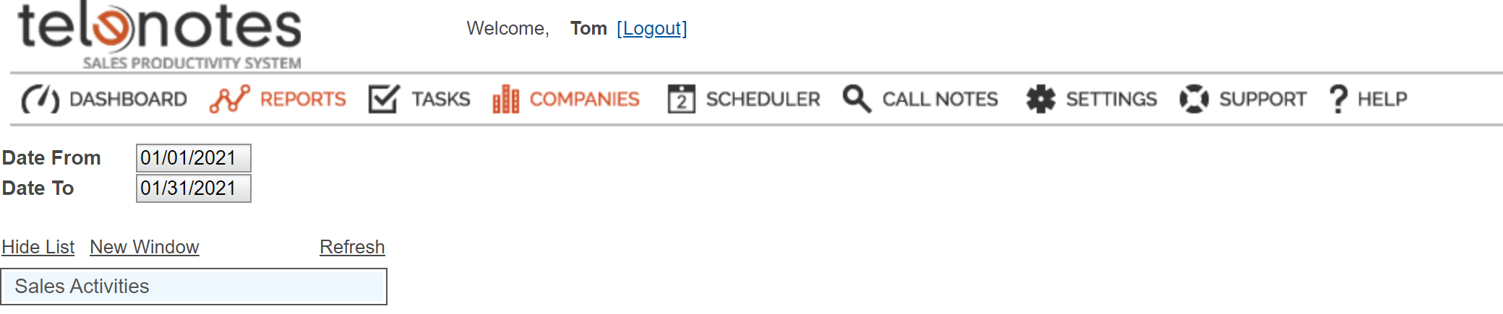
- Click on Sales Activities
- Select K&M TIRE, All Regions
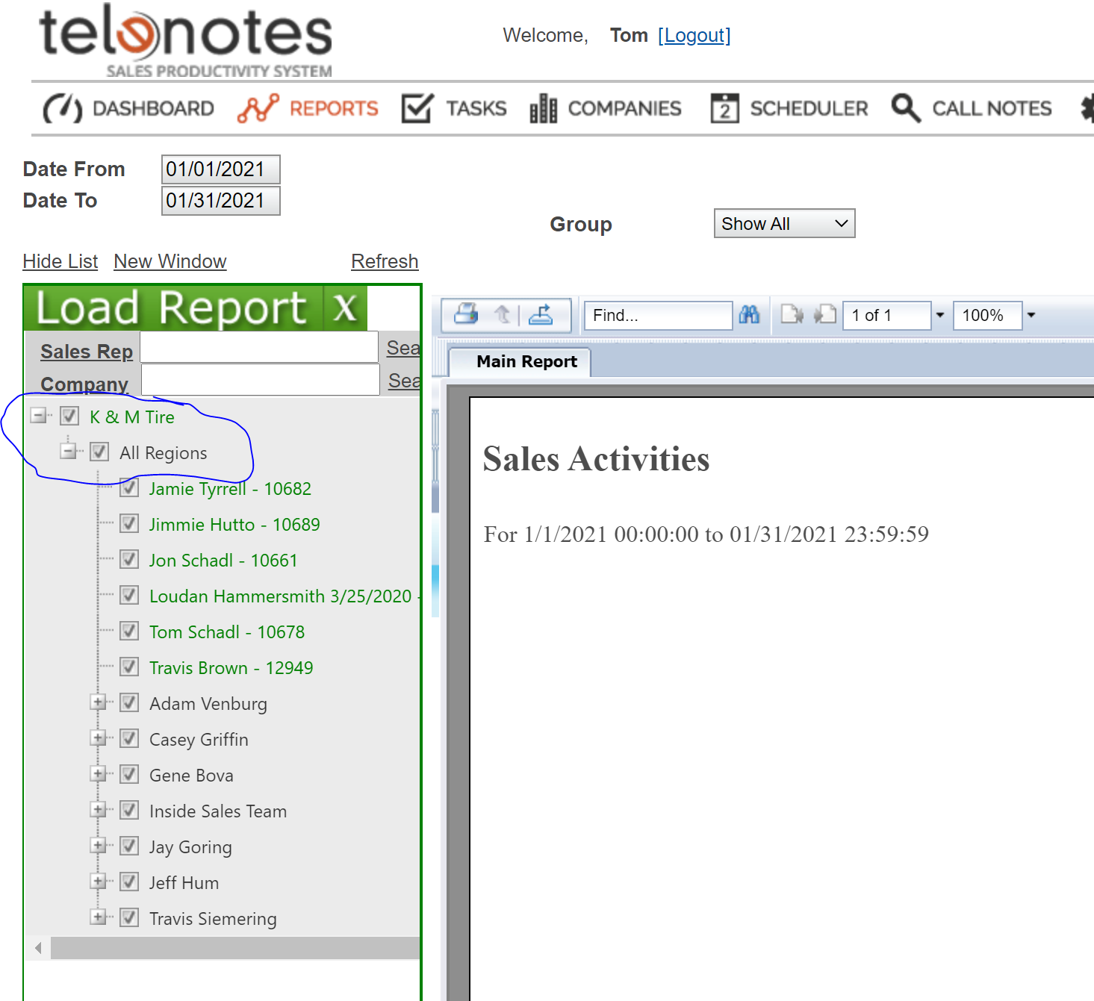
- Click Refresh 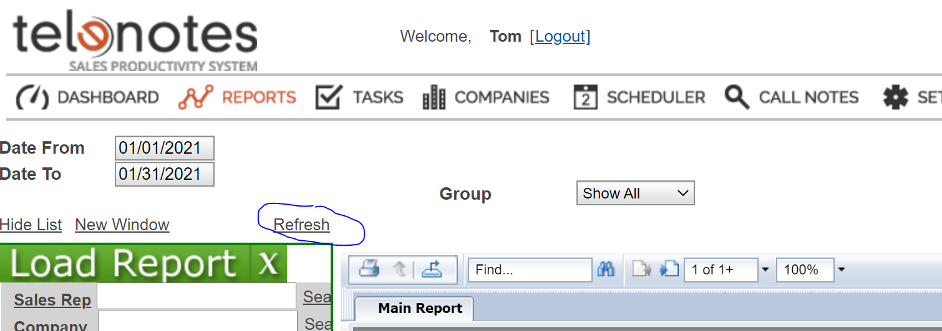

- Click

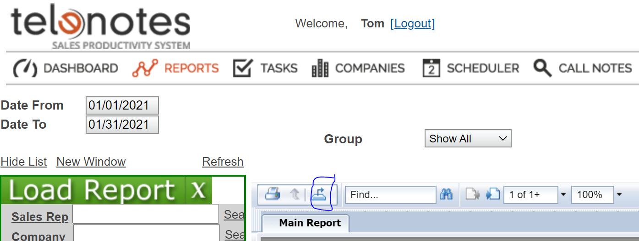
- Click Microsoft Excel (97-2003) Data –Only then export
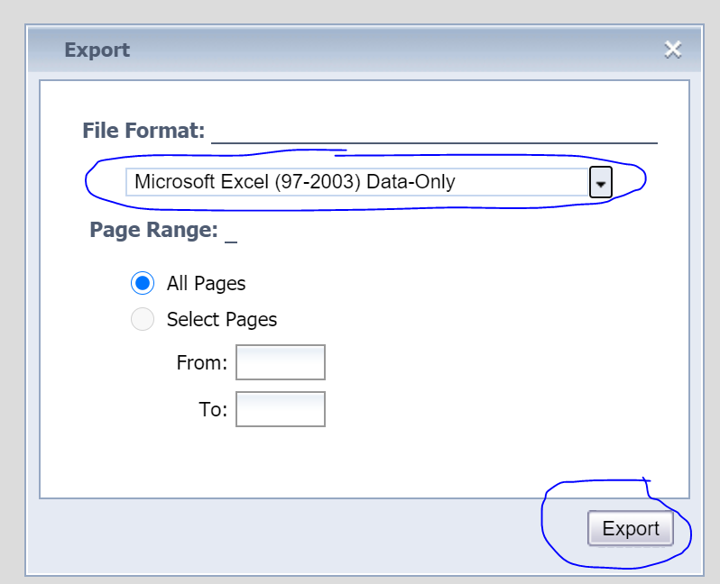
- Your report will populate in the left bottom corner. Then Click on it and it will load in excel.
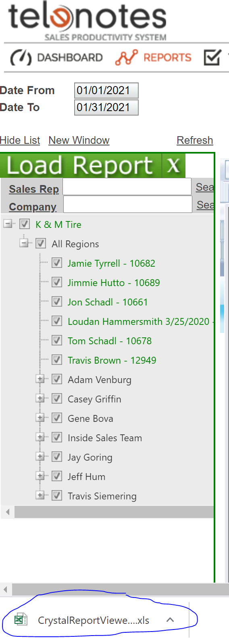
- Delete Rows B,C & U
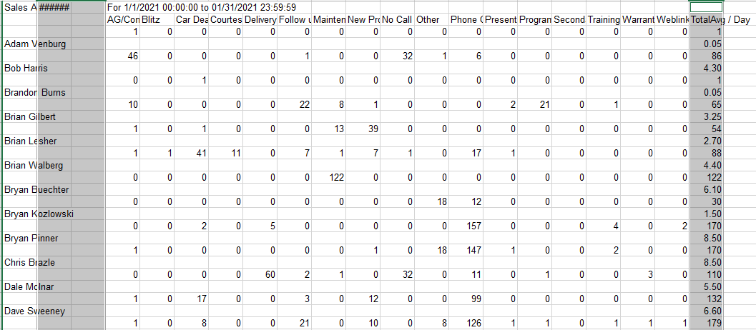
- Delete cell A3 and select shift cells up
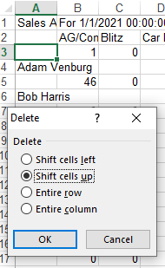
- Delete rows 1&2
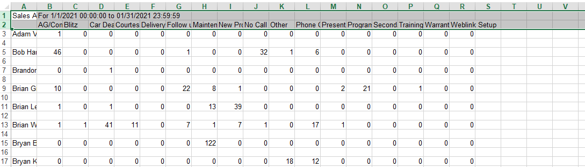
- Highlight all columns that have info.
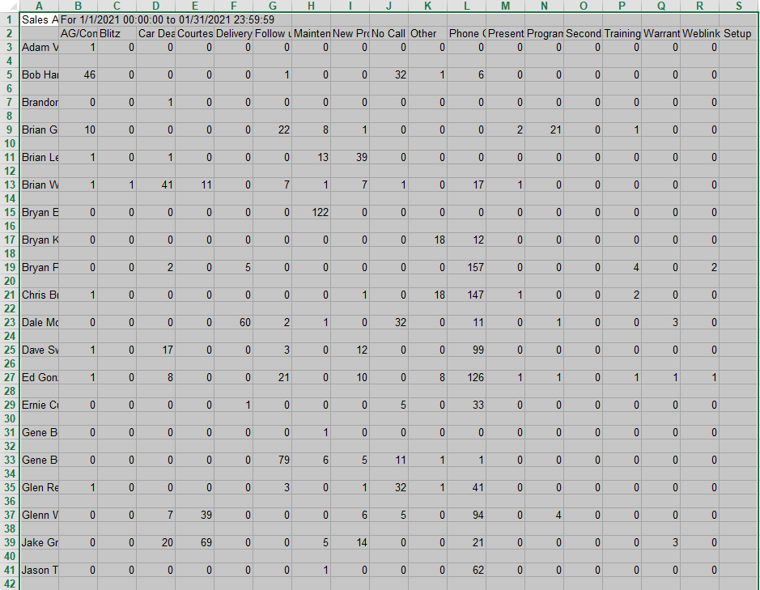

- Click Home

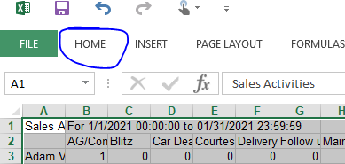
  - Click on Find & Select.
  - Click Go To Special.
  - Click Blanks.
  - Click OK
  - Right Click then Click Delete.
  - Click Shift Cells Up
- Add cells B1 through R1
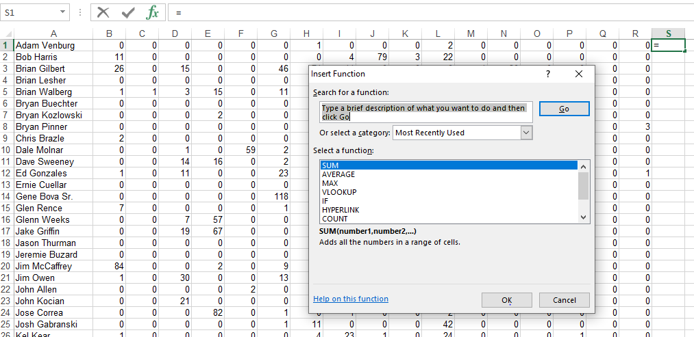
- Double Click Right corner so it will total the whole column.
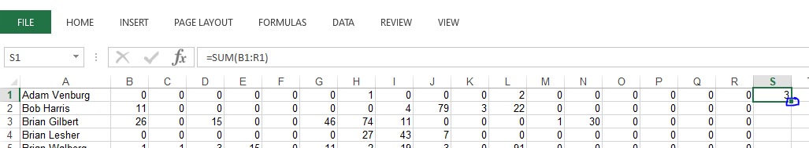
- Click on S to highlight the whole column.
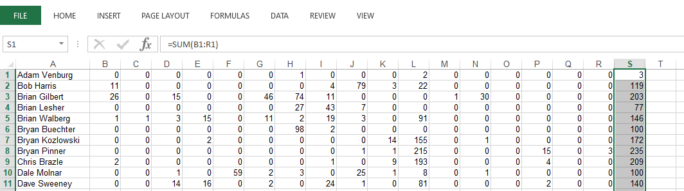
- Hold (Ctrl C) then Right Click mouse in S1 Paste Option 123. This will eliminate the formula.
- Delete columns B through R
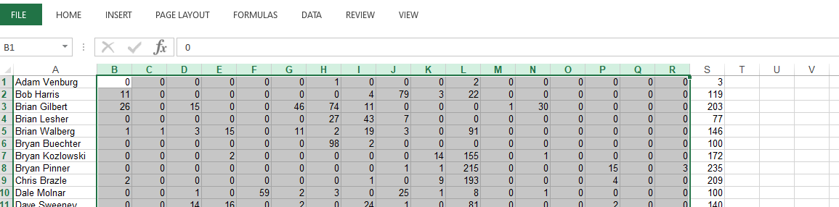
- Copy Column A & B

Adam Venburg | 3
Bob Harris | 119
Brian Gilbert | 203
Brian Lesher | 77
Brian Walberg | 146
Bryan Buechter | 100
Bryan Kozlowski | 172
Bryan Pinner | 235
Chris Brazle | 209
Dale Molnar | 100
Dave Sweeney | 140
Ed Gonzales | 198
Ernie Cuellar | 159
Gene Bova Sr. | 175
Glen Rence | 72
Glenn Weeks | 144
Jake Griffin | 110
Jason Thurman | 87
Jeremie Buzard | 1
Jim McCaffrey | 135
Jim Owen | 245
John Allen | 55
John Kocian | 137
Jose Correa | 86
Josh Gabranski | 54
Kel Kear | 54
Krista Adams | 170
Larry VanKannel | 142
Lawrence Johnson | 210
Luis Garay | 138
Mark Breiding | 170
Mark Ciarlariello | 142
Mike Metzelaars | 37
Randy Wendorf | 152
Rich Kelley | 42
Rudy Martinez | 102
Scott Arnett | 60
Scott Baldauf | 1
Scott Kudlock | 110
Shannon Hutzel | 237
Shawn Hill | 91
Terrance Jacob | 63
Tim Evans | 80
Tim Schroeder | 42
Tom Valletta | 123
Tommy Nguyen | 46
Troy Heitmeyer | 169
Tyler Perrin | 156
  - Paste in Current Years Tab Monthly Telenotes
  - Repeat steps all steps with last year’s dates.
  - Paste in Last Year’s Tab Monthly Telenotes
  - When complete it will calculate you report.
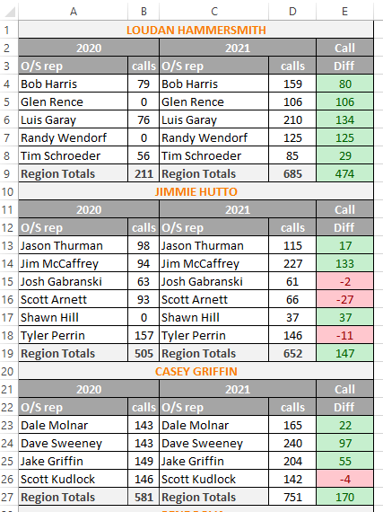
- Click Green arrow in top left corner to highlight page.
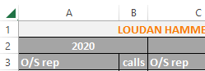

- Click Ctrl C
- Add Page by Clicking +
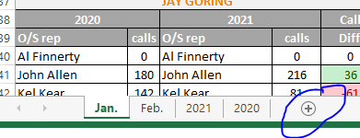
  - Open new page then hit Ctrl V.
  - Go back to current month page in cell A1 then Right Click mouse Paste Options 123
  - After this you should be able clear content in current year and previous year.
  - Email report to the K&M Management group.
- Update Monthly Sellout Report
  - Monthly Sellout
  - Select Current year
  - Select Month you are updating
  - Select VLOOKUP Tab
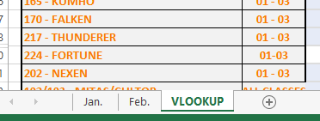
  - Pull up the SA - Customer Ranking Report in the intranet.
  - Select the month you a reporting on and make sure you select Summary for the Report Type.
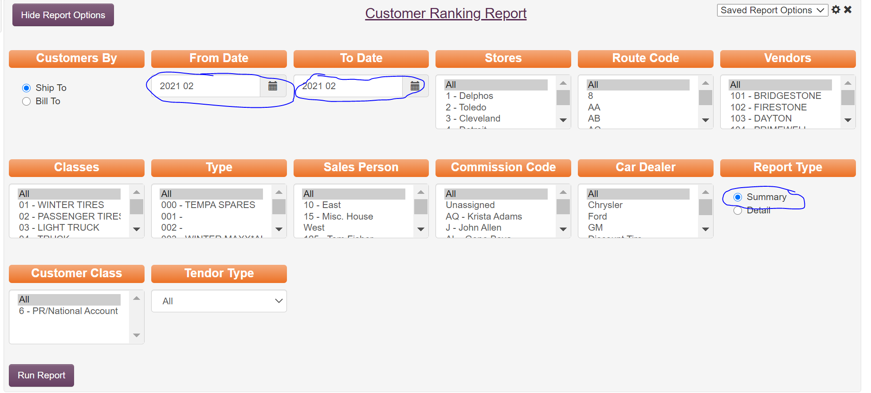
  - Go to VLOOKUP tab on your Monthly Sellout Report to see the first thing you need to populate.
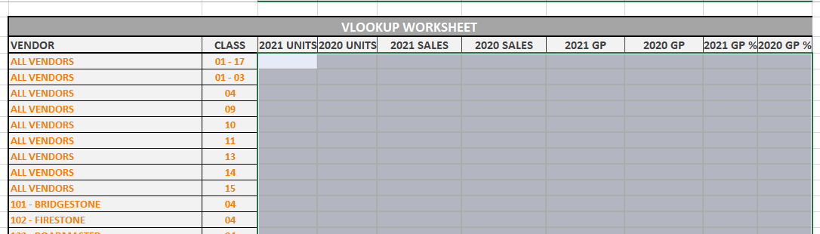
  - Run Customer Ranking Report. Select All Stores, All Route Codes, All Vendors, Classes 1-17, All Type, All Sales Person, All Commission Code, All Car Dealer, Summary for Report Type, All Customer Class & All Tender Type.
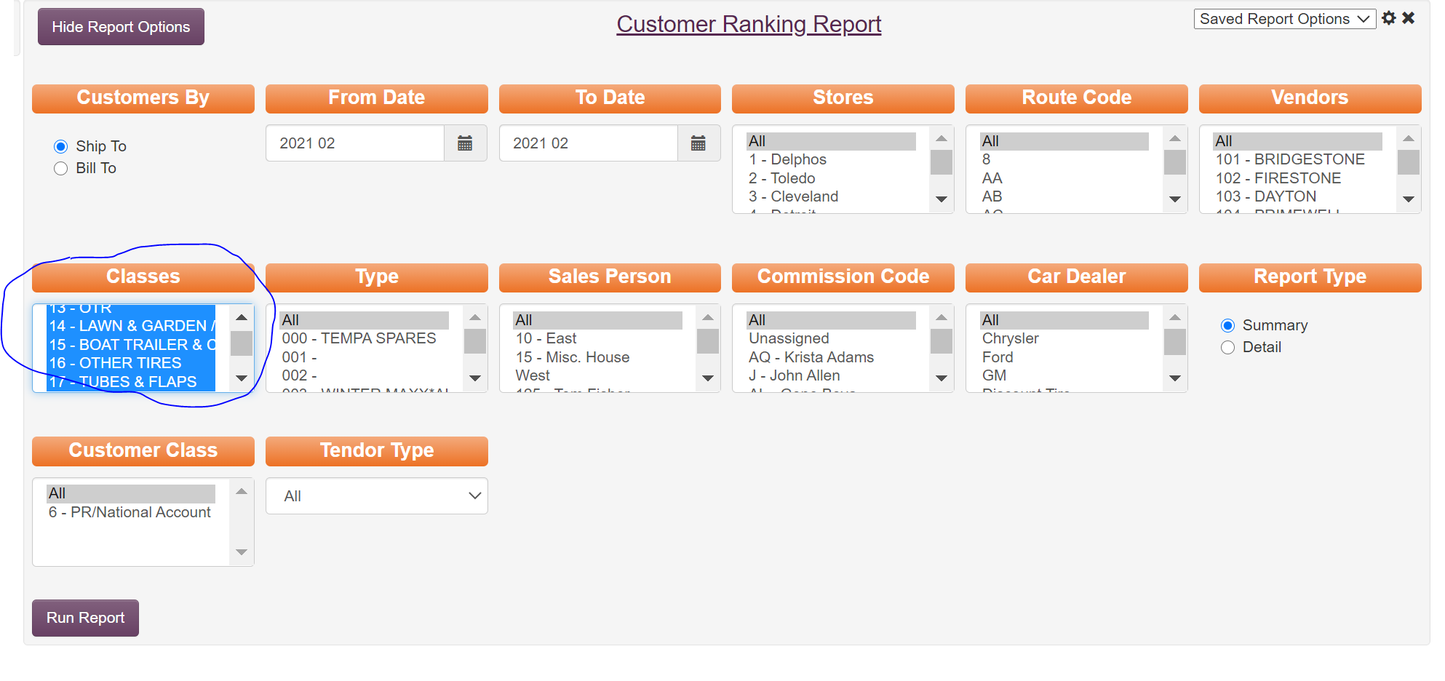
  - Run Report then highlight & Copy Units through Prior Profit Margin
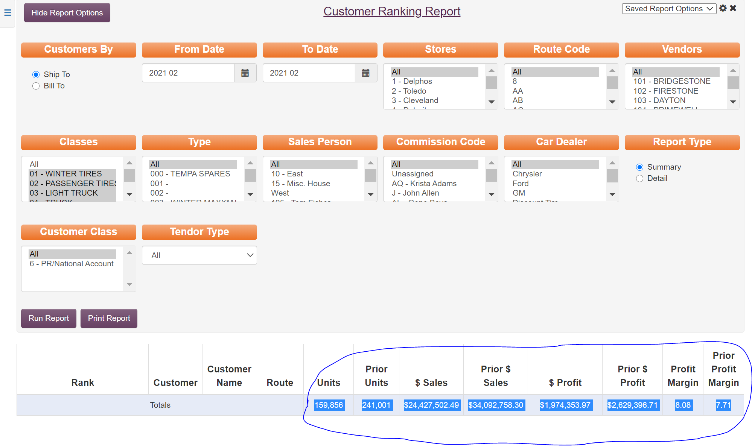
  - Go To you VLOOKUP tab on your Monthly Sellout Report and Past into that line.
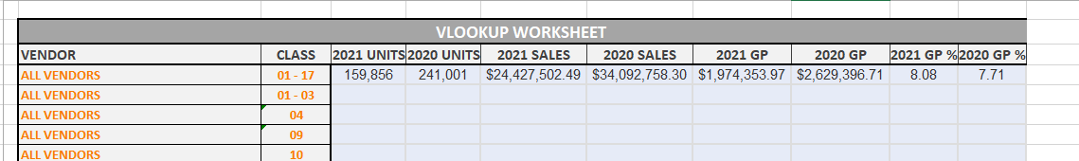
  - To make sure the VLOOKUP worked correctly Click tab of the month you are working on. It should look like this.
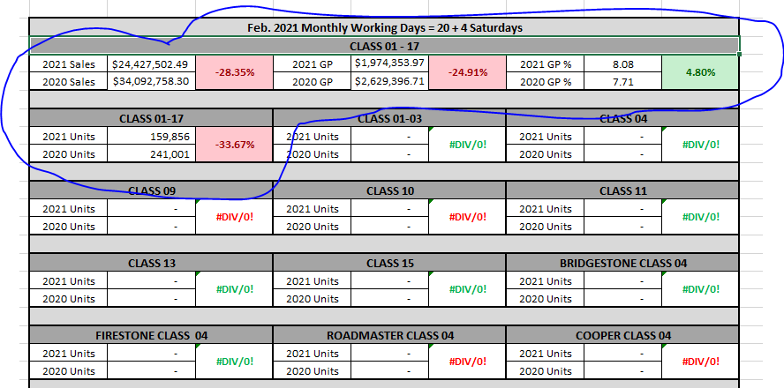
  - Repeat steps E through J until complete.
  - When Complete Make sure The Month & Working Days are correct at the top of this page.
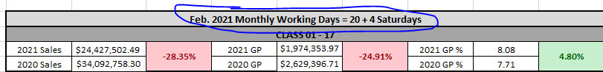
  - Add a New sheet and rename it for the following month.
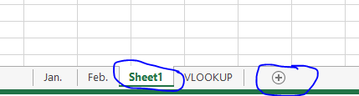
  - Copy the month you just completed and paste it to the following month. This is a very important step because the next step will eliminate the VLOOKUP formulas if you don’t do it correctly.
  - Go back to the month tab you are working on and in Cell A1 Paste 123. This will eliminate the formulas from the VLOOKUP for this tab. To make sure this worked properly you can Click on a cell to make sure the formula is not showing up just the number
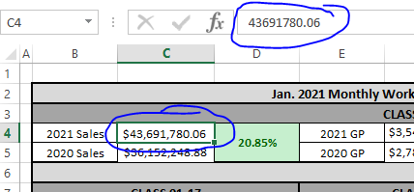
  - When Complete Clear content on the VLOOKUP tab by highlighting, Right Click mouse & select clear content.
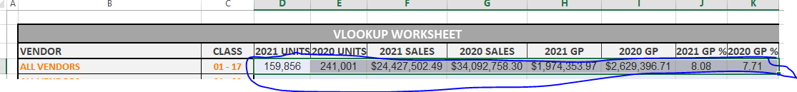
  - Now you are done it is a good time to check the month and work days for the flowing month and remember to save this to the F-Drive.
  - Email this report to the K&M Management Group.
- Update Car Dealer Monthly Sales Report
  - Select Current year
  - Select Month you are updating
  - Select VLOOKUP Tab
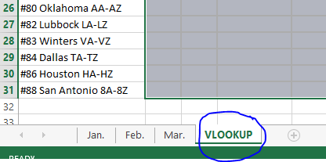
  - Pull up the SA - Customer Ranking Report in the intranet.
  - Select the month you a reporting on and make sure you select Summary for the Report Type. Select Classes 1-3 only and under Car Dealer select Ford, GM, Chrysler& Other.
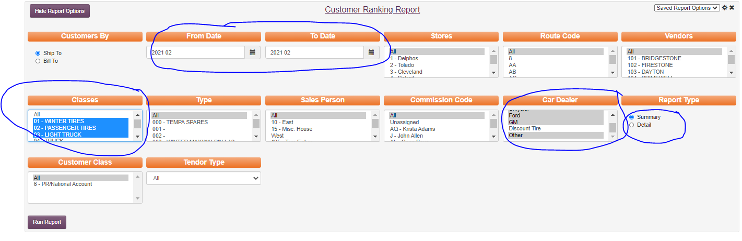
  - Now it is time to select what Route codes to run. Open the VLOOKUP tab and highlight the routes shown in that line.
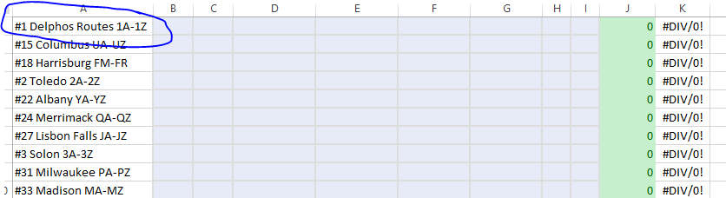
  - Run the report and Copy Units though Prior Profit Margin
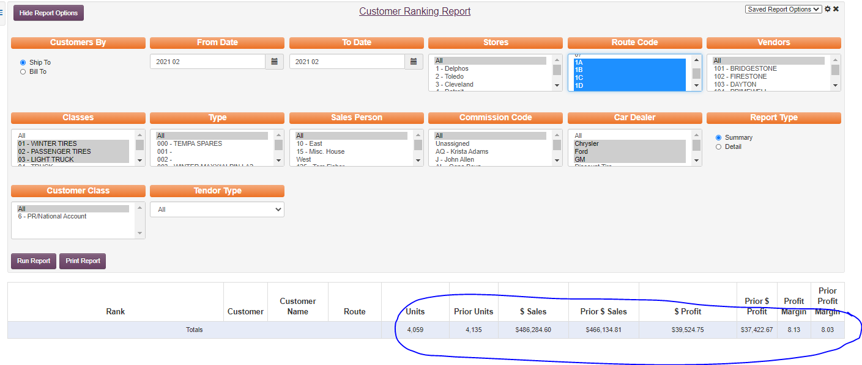
  - Paste in VLOOKUP tab.
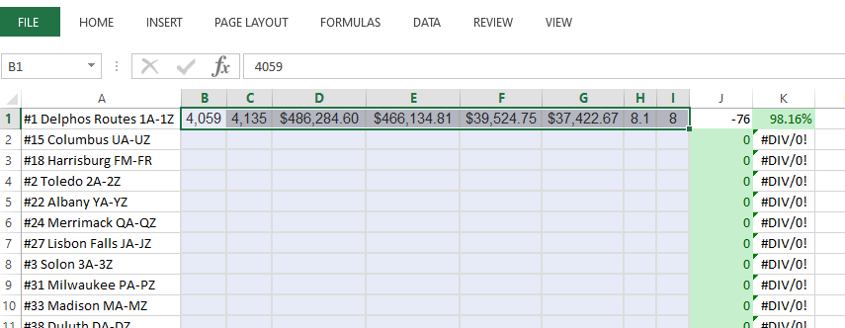
  - It should show up in the Month you are working with like below.
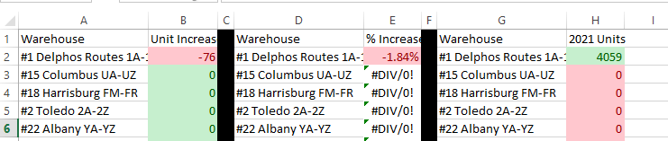
  - Repeat steps E-J until VLOOKUP Table is full.
  - Copy the month you just completed and paste it to the following month. This is a very important step because the next step will eliminate the VLOOKUP formulas if you don’t do it correctly.
  - Go back to the month tab you are working on and in Cell A1 Paste 123. This will eliminate the formulas from the VLOOKUP for this tab. To make sure this worked properly you can Click on a cell to make sure the formula is not showing up just the number
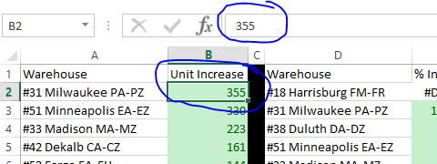
  - Highlight B2,A2-B32,A32 then Click the Home Button, Sort & Filter & Largest to Smallest

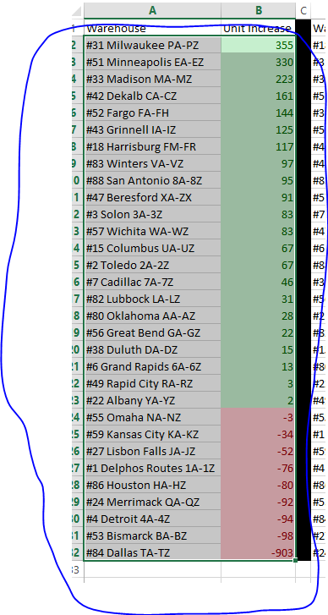
  - Repeat step N for E&D Columns and H&G Columns
  - You can now clear content in the VLOOKUP tab.
  - Email this report to the K&M Management Group.
- Monthly Communication (write own and read all others)
  - F:\Sales\Shared\Director of Sales\Monthly Communication
- Review Fuel Report
  - Logistic will send you a fuel report the 1st of each month

Frequently Asked Questions
K&M instructions: Provide information on how the Warehouse Manager can get emergency assistance and system support (e.g., help desk support, inventory support, etc.). Include the names of the responsible personnel and organization(s), telephone numbers, and email addresses of the staff who serve as points of contact for system support.

Table 1 - Support Points of Contact
Contact / | Department | Phone | Email | Role
K&M Corporate Line | Corporate | 419-695-1061 | n/a

Other
    - other

Appendix A: Miscellaneous
Add links here

Appendix B: Supportive Department Summaries
How we can help at the field level?
Inventory Specialist:
Sales Department:
Purchasing Department:
Credit Department:

Instructions: Provide a list of acronyms and associated literal translations used within the document. List the acronyms in alphabetical order using a tabular format as depicted below.

Table 2 - Acronyms
Acronym | Literal Translation
<Acronym> | <Literal Translation>

Appendix C: Glossary
Instructions: Provide clear and concise definitions for terms used in this document that may be unfamiliar to readers of the document. Terms are to be listed in alphabetical order.
Table 3 - Glossary
Term | Acronym | Definition
Appendix D: Referenced Documents

Table 4 - Referenced Documents
Document Name | Document Location and/or URL | Issuance Date
Appendix E: Approvals
The undersigned acknowledge that they have reviewed the User Manual and agree with the information presented within this document. Changes to this User Manual will be coordinated with, and approved by, the undersigned, or their designated representatives.
Instructions: List the individuals whose signatures are desired. Examples of such individuals are Business Owner, Project Manager (if identified), and any appropriate stakeholders. Add additional lines for signature as necessary.
Table 5 - Approvals
Document Approved By | Date Approved
Name: <Name>, <Job Title> - <Company> | Date
Name: <Name>, <Job Title> - <Company> | Date
Name: <Name>, <Job Title> - <Company> | Date
Name: <Name>, <Job Title> - <Company> | Date
Appendix F: Additional Appendices
K&M Usage: Utilize additional appendices to include additional data, charts, etc..

Appendix G: Notes to the Author/Template Instructions
This document is a template for creating a User Manual for a given investment or project. The final document should be delivered in an electronically searchable format. The User Manual should stand on its own with all elements explained and acronyms spelled out for reader/reviewers, including reviewers outside CMS who may not be familiar with CMS projects and investments.
This template includes instructions, boilerplate text, and fields. The developer should note that:
- Each section provides instructions or describes the intent, assumptions, and context for content included in that section. Instructional text appears in blue italicized font throughout this template.
- Instructional text in each section should be replaced with information specific to the particular investment.
- Some text and tables are provided as boilerplate examples of wording and formats that may be used or modified as appropriate.
When using this template, follow these steps:
- Table captions and descriptions are to be placed left-aligned, above the table.
- Modify any boilerplate text, as appropriate, to your specific investment.
- Do not delete any headings. If the heading is not applicable to the investment, enter “Not Applicable” under the heading.
- All documents must be compliant with Section 508 requirements.
- Figure captions and descriptions are to be placed left-aligned, below the figure. All figures must have an associated tag providing appropriate alternative text for Section 508 compliance.
- Delete this “Notes to the Author/Template Instructions” page and all instructions to the author before finalizing the initial draft of the document.
Appendix H: Revision History Tracking
The following table records information regarding changes made to the Operations Binder.

Table 6 - Revision History Tracking
Version Number | Date | Author/Owner | Description of Change

